EXPERIMENT 3

RELATIONAL MODEL FOR A COLLEGE DATABASE

**Aim**: Draw a relational model for a college database

**Components:**

1. Tables:
   1. Student
   2. College
   3. Course offerings
   4. Course
   5. Faculty
2. Degree
   1. Student – 4
   2. College – 3
   3. Course offerings – 3
   4. Course – 3
   5. Faculty – 3

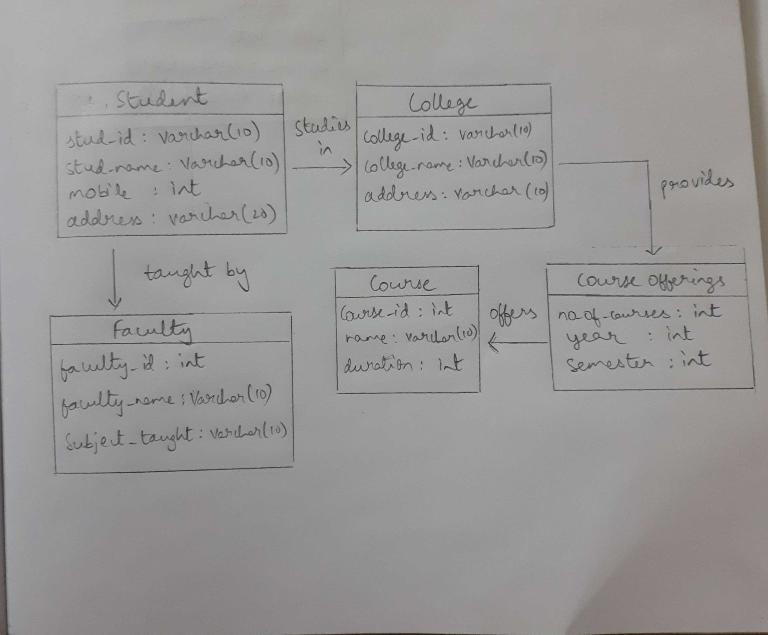

|  |  |
| --- | --- |
| Student | studies in |
| Stud_id | varchar(10) |
| Stud_name | varchar(10) |
| mobile | int |
| address | varchar(20)  provides |

|  |  |
| --- | --- |
| College |  |
| college_id | varchar(10) |
| college_name | varchar(10) |
| address | varchar(20) |

taught by

|  |  |
| --- | --- |
| Course offerings |  |
| no_of_courses | int |
| year | int |
| semester | int |

|  |  |
| --- | --- |
| Faculty |  |
| faculty_id | varchar(10) |
| faculty_name | varchar(10) |
| subj_taught | varchar(10) |

|  |  |
| --- | --- |
| Course |  |
| course_id | Varchar(10) |
| course_name | Varchar(10) |
| duration | int |

offers